**Input and output stream in java-**

**Java I/O** (Input and Output) is used to process the input*and*produce the output*.*

Java uses the concept of a stream to make I/O operation fast. The java.io package contains all the classes required for input and output operations.

We can perform **file handling in Java** by Java I/O API.

**Stream**

A stream is a sequence of data. In Java, a stream is composed of bytes.

In Java, 3 streams are created for us automatically. All these streams are attached with the console.

**1) System.out:**standard output stream, that is used to produce the result of a program on an output device like the computer screen.

**2) System.in:**standard input stream, that is used to read characters from the keyboard or any other standard input device.

**3) System.err:**standard error stream, that is used to output all the error data that a program might throw, on a computer screen or any standard output device.

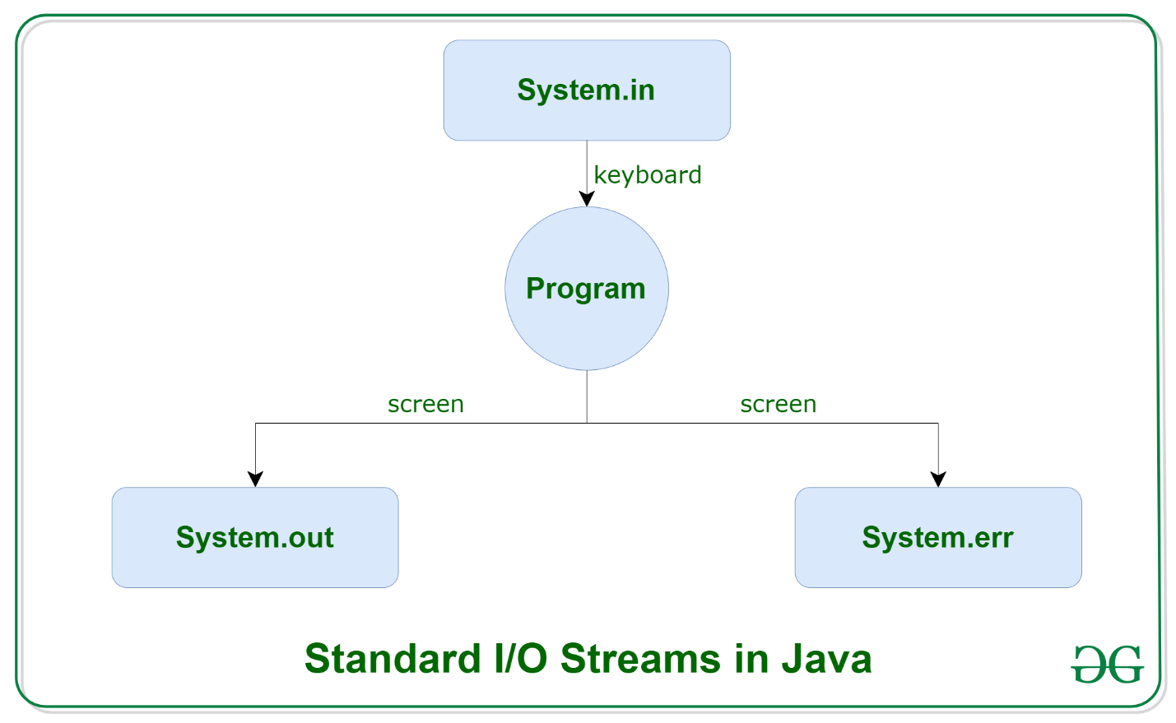

Let's see the code to print **output and an error** message to the console.

1. System.out.println("simple message");
2. System.err.println("error message");

The explanation of OutputStream and InputStream classes are given below:

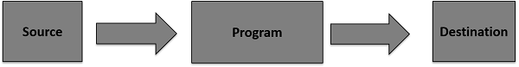

**Output Stream**

Java application uses an output stream to write data to a destination; it may be a file, an array, peripheral device or socket.

**Input Stream**

Java application uses an input stream to read data from a source; it may be a file, an array, peripheral device or socket.

Let's understand the working of Java OutputStream and InputStream by the figure given below as-







**Example-**

**1.Read a file line by line using Scanner class**

import java.io.*;

import java.util.Scanner;

public class ReadLineByLineExample2

{

public static void main(String args[])

{

try

{

//the file to be opened for reading

FileInputStream fis=new FileInputStream("Demo.txt");

Scanner sc=new Scanner(fis);    //file to be scanned

//returns true if there is another line to read

while(sc.hasNextLine())

{

System.out.println(sc.nextLine());      //returns the line that was skipped

}

sc.close();     //closes the scanner

}

catch(IOException e)

{

e.printStackTrace();

}

}

}

**Example- Write the file using File Writer class**

In this example, we are writing the data in the file testout.txt using Java FileWriter class.

package com.test

import java.io.FileWriter;

public class FileWriterExample {

    public static void main(String args[]){

         try{

           FileWriter fw=new FileWriter("D:\\testout.txt");

           fw.write("Velocity corporate training center pune.");

           fw.close();

          }catch(Exception e){System.out.println(e);}

          System.out.println("Success...");

     }

}